AI Myths and Facts: Separating What’s Real from the Hype
--- By Ayush Singh Rathor, B.Tech CSE (AI & ML), VIT
From JEE Problems to AI Prompts: An Introduction.
Despite taking several years to prepare, I finally succeeded in getting into the engineering branch where I had set my sights.
VIT has a CSE program in CSEN, which includes courses in Artificial Intelligence and Machine Learning.
Like many other engineering students, I was raised around technology and gadgets, programming especially, but AI always had its own distinct feel to it. The appearance of machines that could think, create, and converse seemed to be from a science fiction perspective.
In the present day, AI is ubiquitous. You can count on it to suggest the next video you watch, navigate traffic properly, filter out spam emails or junk mail, modify photos, write essays, and create art. ChatGPT, machine learning and generative AI have become terms that are used in everyday conversation within a few years.
Despite the excitement, there is a great deal of confusion. However, it is believed by some that AI may soon take over the world. Others believe it's always correct. The general belief is that it can solely be used by individuals in the programming and technology fields. There is a much more captivating and less dramatic reality.
I want to dispel some of the biggest misconceptions about AI and differentiate between reality and fiction in this blog.
------------------------------------------------------------------------------------------------------------------------------------------------------
What Exactly Is AI?
Artificial Intelligence, or AI, is a broad term used for computer systems that perform tasks requiring human-like intelligence. These tasks include learning from data, recognising patterns, understanding language, making recommendations, and solving problems.
AI isn't a new concept. Simple AI has been present in video games, search engines, automated customer service systems, and recommendation systems for decades. Moreover, many advanced AI technologies are still being developed.
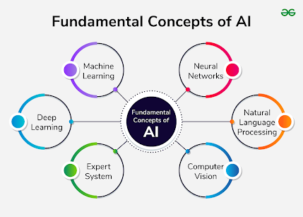

Nowadays, when people talk about AI, they tend to make a big deal about it.
Machine Learning (ML)
An area of artificial intelligence where systems learn from data and improve over time rather than following fixed instructions.
Having grasped the basics of AI, let's decipher some familiar myths.
------------------------------------------------------------------------------------------------------------------------------------------------------
Myth #1: AI is set to dominate the world, according to a mythic notion.
This is probably the most popular myth, thanks to movies and science fiction stories. The idea of super-intelligent machines controlling humanity sounds exciting, but it is far from reality.
Modern AI systems are engineered to serve a purpose.
Specific tasks:
.
A text-generating AI cannot operate a car, bank account, or power grids without human intervention. Why? Because the most intelligent AI can't control an electric bank, which isn't
AI lacks any specific aims, feelings, goals, or desires. It doesn't “want” anything. The system's functionality is based on its ability to recognise patterns from data and react to the input it receives.
This isn't a takeover by AI; it's just about solving the real problem.
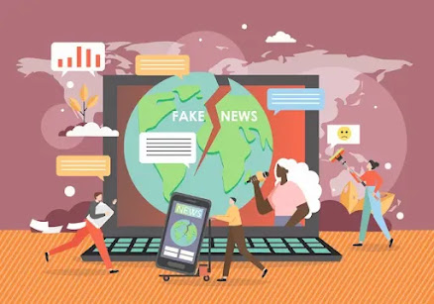

How humans use AI:
Science-fiction scenarios are not as important as issues of misinformation, privacy, bias in algorithms, and excessive reliance on AI. Why?
Fact:
AI is a system that is designed and engineered by humans.
ns. People are always responsible for its actions, not machines.
-----------------------------------------------------------------------------------------------------------------------------------------------------
Myth #2: Artificial Intelligence Is Always Correct.
Many people assume that if an AI can provide a response with confidence, it must be accurate. Unfortunately, that isn't true.
Patterns acquired from vast amounts of text are used in ChatGPT, a language model that predicts the most probable arrangement of words. Unlike humans, they lack the ability to comprehend facts.
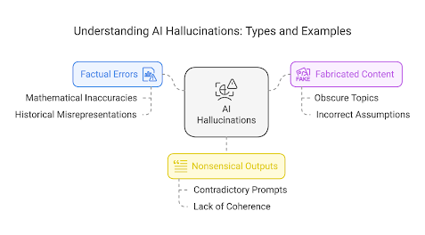
This leads to the creation of information that appears convincing but is entirely inaccurate, generated by AI. False dates, references to other sources, or inaccurate explanations may be generated by it. An umbrella term is frequently used to describe this phenomenon.
AI hallucination.
The limitations of AI are due to:
- There may be biases or inaccuracies in training data.
- Information may become outdated.
- The complexity of reasoning may persist in AI.
- Despite the certainty of an answer, it's not always accurate.
Fact:
It is crucial to ensure that you are getting the correct information, particularly in fields like academia and law, healthcare, finance, and research.
------------------------------------------------------------------------------------------------------------------------------------------------------
Myth 3: Only technologists are allowed to use AI?
This myth could not be further from the truth.
AI tools of today are available to anyone. AI tools designed to be user-friendly for students, artists, teachers, entrepreneurs, and professionals. Why?
You are capable of using AI by typing a question in everyday language. Why?



You are already utilising AI on a daily basis:
- Google Maps suggests routes.
- Netflix recommends movies.
- Your phone organises photos.
- Email filters spam.
- Voice assistants answer questions.
The majority of widely used AI tools are accessible through websites or apps and require minimal technical expertise.
Compulsory skills in math and programming, as well as data science/machine learning are needed to build AI systems. Search engines are now the primary means of utilizing AI.
Fact:
AI can be used effectively without coding knowledge. How? Asking the right questions is crucial.
------------------------------------------------------------------------------------------------------------------------------------------------
The Bigger Picture:
There is no magic formula for every problem or threat, and AI is not a machine to be conquered. Education, business, healthcare, entertainment, and daily life are all being transformed by this powerful tool.
Like any technology, AI has its advantages and disadvantages. Why? Using it with care requires knowledge of both.
The study of AI and ML is no longer solely the responsibility of engineers, in my opinion. This is becoming a fundamental ability for all.
We are only now entering the realm of AI. Upcoming blogs I'm exploring: machine learning, generative AI; how does it matter in real-life applications; where to start when starting on projects with AI for students?
Until then, stay curious, continue to learn, and remember:.

AI's objective is to enhance human in
telligence, not to replace it.
Thanks for reading! 🚀.

